GALEN

He was a doctor who studied anatomy (the study of body structure). To learn about inner organs, Galen cut open dead animals and took notes on what he learned.

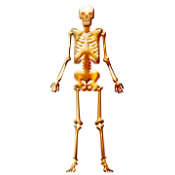
PTOLEMY
He studied the sky and carefully mapped over 1,000 different stars. He also studied the motion of the planets and stars, and created rules explaining their movement.
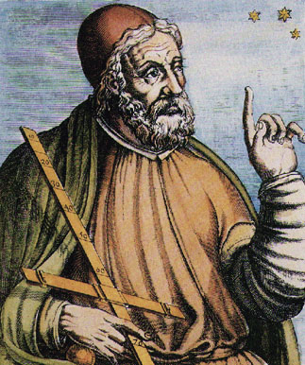

LIVY
One of Rome’s most famous historians, Livy wrote a book called History of Rome. He describes how Rome became powerful. Livy admired the actions of the early Romans, and he believed that history had important lessons to teach people.

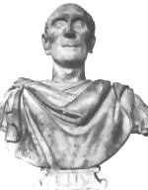

VIRGIL
He wrote an epic poem called “Aeneid.” The poem tells the story of a Trojan (from what is now Turkey) prince who comes to Italy. The prince is considered brave, self-controlled, and loyal to the gods. He was influenced by the Greek writer Homer.

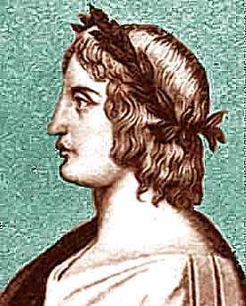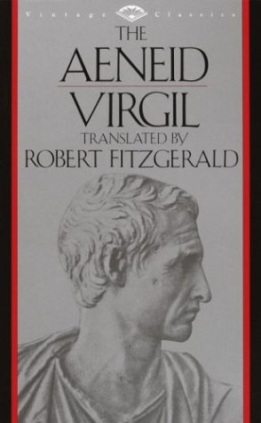
OTHER ROMAN ACHIEVEMENTS
- Aqueducts—man-made channels that brought water from far away to cities
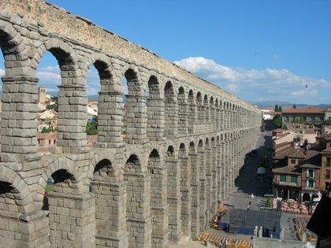
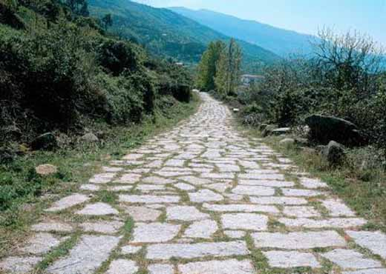
- Roads—20,000 miles of roads were built to connect the empire

- Latin Language-- spoken by Romans, late used by Europeans for government, trade, and learning. Many modern languages come from Latin, such as Italian, French, Spanish, Portuguese, and some English words

