McDougal Geometry chapter 11 notes

11.1 Areas of triangles and parallelograms: pg 723 #3-33 odds, 36-44E. Bring graph paper, straightedge, scissors, and tape tomorrow.

Read 3 new postulates and 3 new theorems on pages 720-721.

Prove that area of a parallelogram is base times height.

Prove that the area a triangle is one half of base times height.

GP 2-4.

Redo example 3 if there is a 5 foot by 10 foot rectangular window. How much area needs painting? Use conversion analysis (stoichiometry) to show how much paint to buy. (Use the back of this page.)
11.2 Area of trapezoids, rhombuses, and kites, pg 733 #3-41 odds (skip 33)

Do activity 11.2 area of trapezoids and kites on page 729. (Need graph paper, straightedge, scissors, and tape.)

TK#109: Area formulas:
Area of a square=(side)²
Area of a rectangle=bh
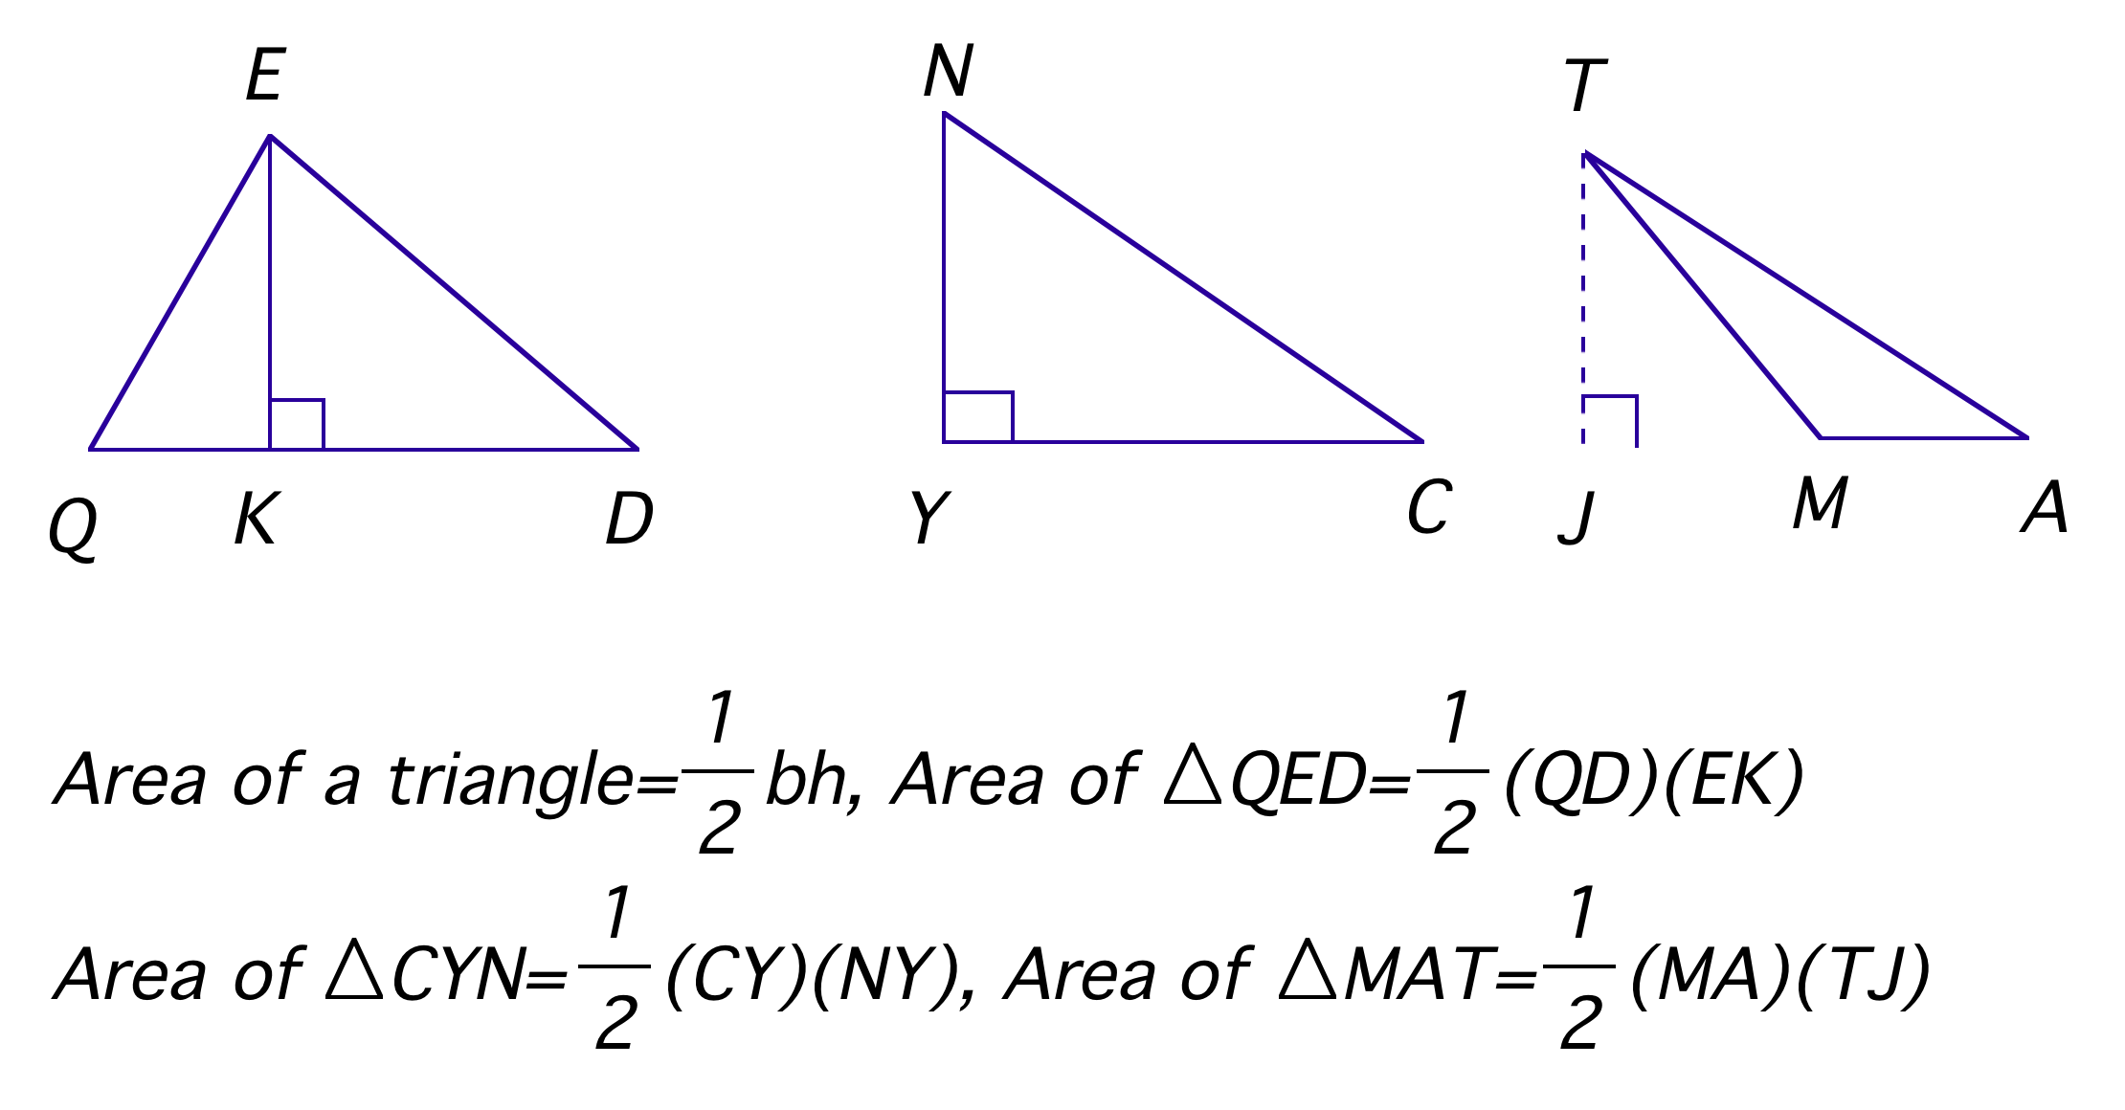
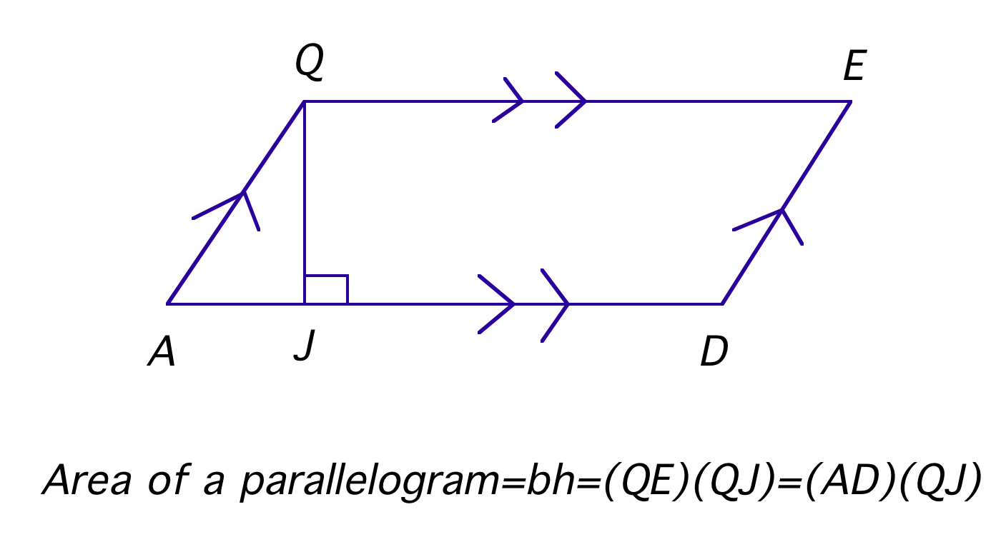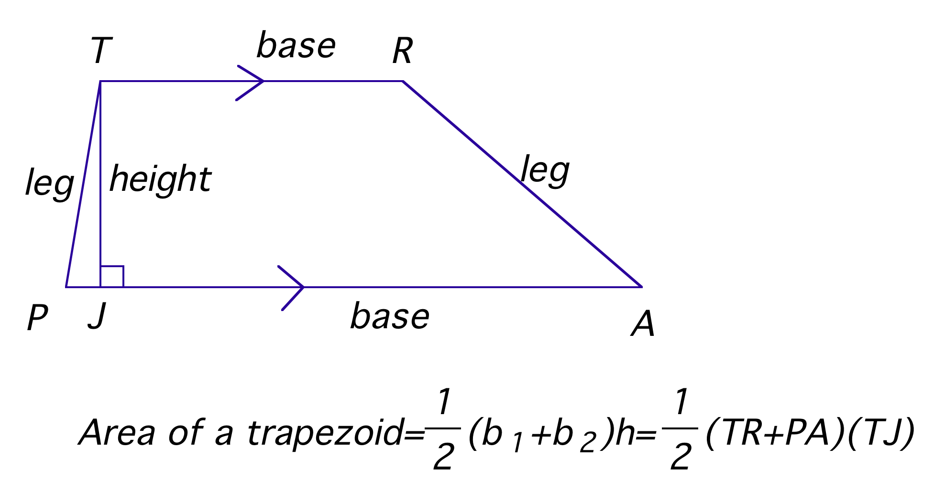

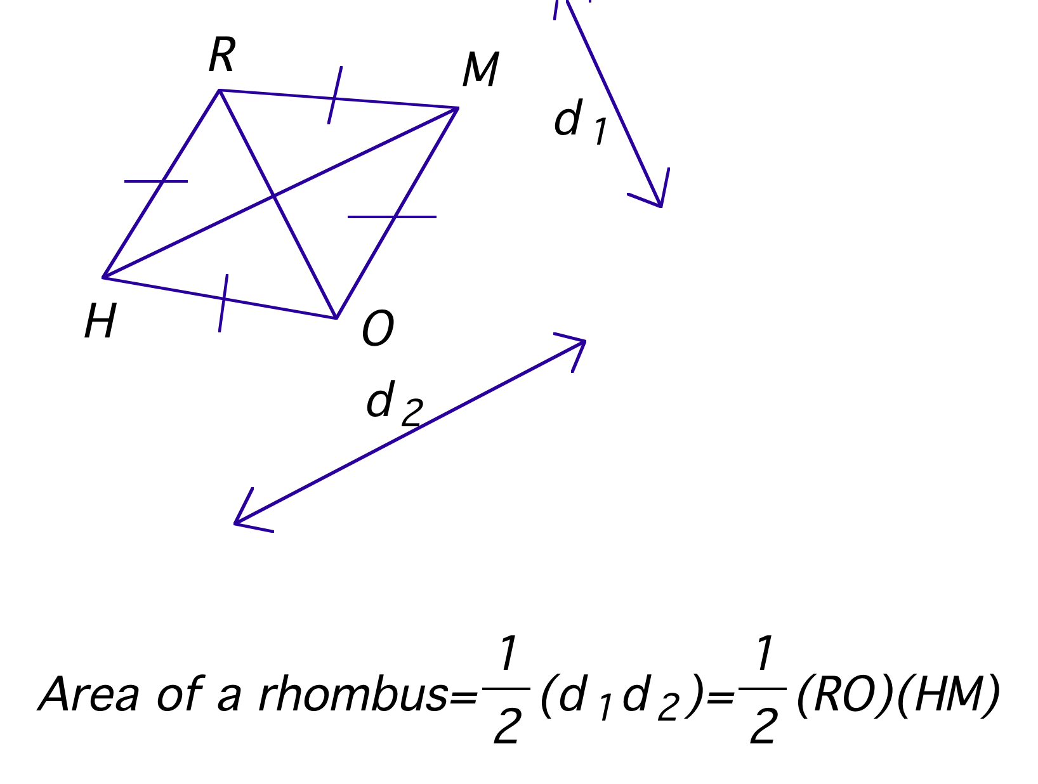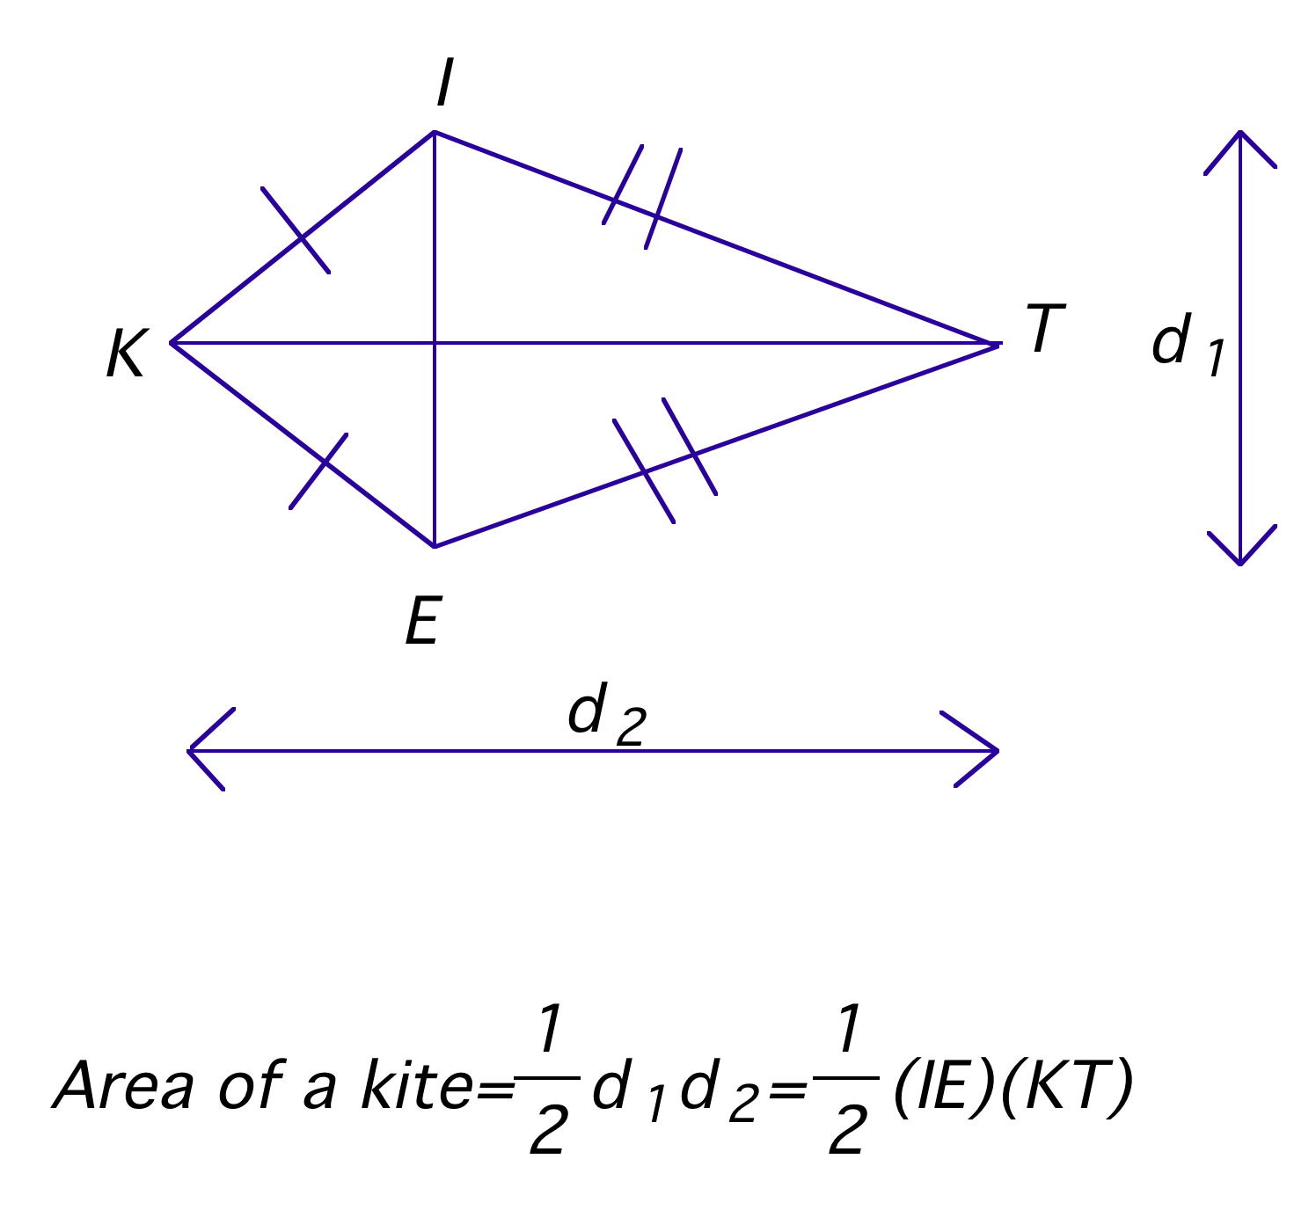
GP 1-5.

11.2 day 1 hwk: pg 733 #3-31 odds, 34-40E
11.2 day 2 hwk: pg 734 #16-32E, 35-41 odds

11.3 Perimeter and area of similar figures, pg 740 #2, 3-21 odds, 26, 28
12.7 Explore similar solids, pg 850 #3-17 odds and bring graph paper, calculator, and 2 large round objects tomorrow (bigger is better!)

TK#110: Similarity thm: If 2 figures are similar, then:
*ratio of corresponding sides (or anything 1-D)=scale factor
*ratio of corresponding areas=(scale factor)²
*ratio of corresponding volumes or weights=(scale factor)³

11.3 GP 1-3.
12.7 GP 1-3.

Circumference activity: need 2 large round objects, measuring tape, calculator
11.4 Circumference and arc length, pg 750#7-39 odds (skip 33) and bring scissors and tape tomorrow

TK#111: Circumference of a circle$C=2pr=pd$
where C=circumference, r=radius, d=diameter

TK#112: Arc length corollary: In a circle, the ratio of the arc length to the circumference is equal to the ratio of the measure of the arc to 360⁰.
$$\frac{{\text{arc}}_{{\text{length}}_{{\overset{Ç}{\text{of}}}_{\text{AB}}}}}{2pr}=\frac{m\overset{Ç}{\text{AB}}}{\text{360}°},$$
$${\text{arc}}_{{\text{length}}_{{\overset{Ç}{\text{of}}}_{\text{AB}}}}=\frac{m\overset{Ç}{\text{AB}}}{\text{360}°}\left(2pr\right)$$

GP1, 3, 5: Give exact answers in terms of $p$. NO decimals!

GP2: Use stoichiometry and don’t forget to put $\text{28}p$ in parenthesis when you divide.

GP4, 6.

Area of a circle activity: need scissors and tape
11.5 Areas of circles and sectors, pg 758#9-37 odds, 43

TK#113: Area of a circle: $A={pr}^{2}$ where A=area, r=radius

TK#114: Area of a sector: The ratio of the area of a sector to the area of the whole circle is equal to the ratio of the measure of the intercepted arc to 360⁰.
$$\frac{{\text{area}}_{\text{of}}\text{_sec}\text{torAPB}}{{pr}^{2}}=\frac{m\overset{Ç}{\text{AB}}}{\text{360}°},$$
$${\text{area}}_{\text{of}}\text{_sec}\text{torAPB}=\frac{m\overset{Ç}{\text{AB}}}{\text{360}°}\left({pr}^{2}\right)$$

GP4 GP5: Give exact answers in terms of $p$. NO decimals!
11.6 Areas of regular polygons, pg 765 #1-4, 5-39 odds (skip 35), 40 (need a compass), 42

Read the top 3 paragraphs on page 762 for the definition of apothem and central angle of regular polygon.

Go through the derivation of the formula for the area of a regular n-gon at the top of page 763.

TK#115: Area of a regular n-gon
The area A of a regular n-gon with side length s, apothem a, and perimeter P is
$$A=\frac{1}{2}\text{aP}=\frac{1}{2}\text{ans}\text{.}$$
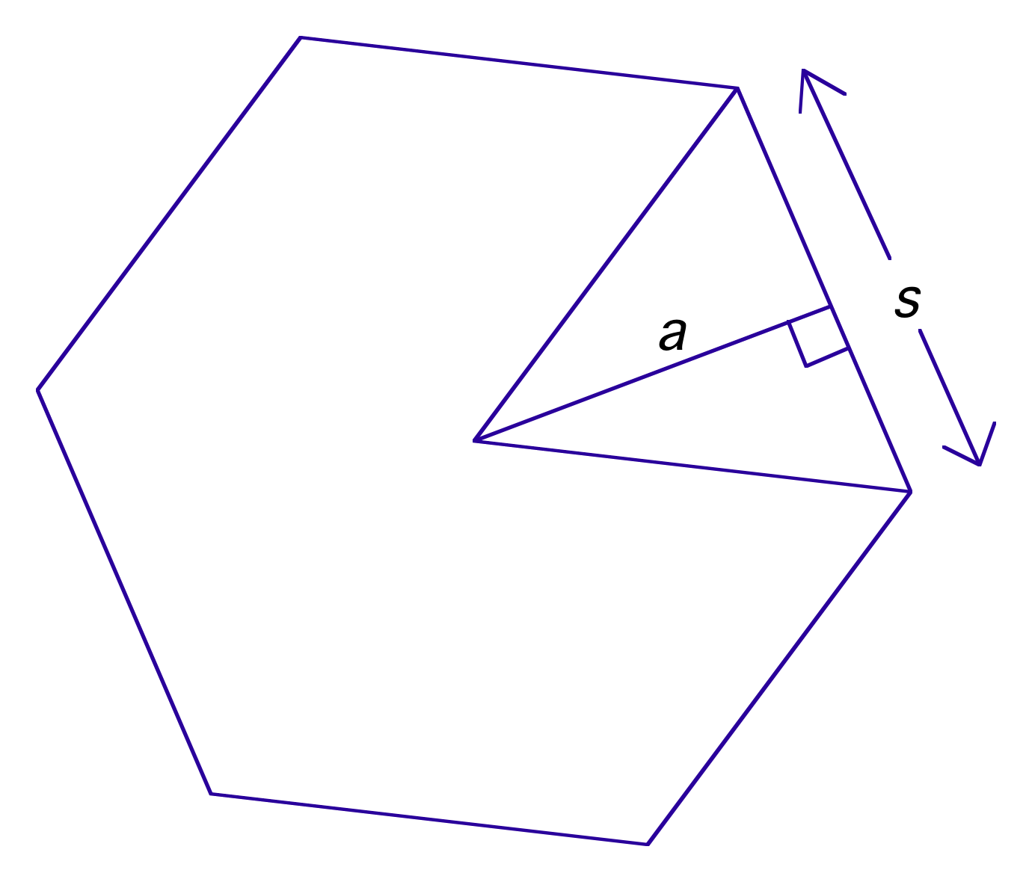

Example 1.

GP 3-6.

11.6 day 1 hwk: pg 765 #1-4, 5-33 odds, 40 (need a compass)
11.6 day 2 hwk: pg 766 #20-34E, 35-39 odds, 42

11.7 Geometric probability, pg 774#9-37 odds

GP3-6.

_________ch 11 rev: pg 780 #5-26.
_________ch 11 gp quiz.
_________correct gp quiz
_________Turn in TK#1-115. Ch 11 test
_________ Activity to figure out relationship between edges, vertices and faces in a polyhedron.
Euler’s Theorem for Polyhedron

Materials needed: 25 gumdrops per group, 40 toothpicks per group

Using the gumdrops and toothpicks, build the following polyhedra. If you can, build each polyhedron more than one way. Indicate how many ways you can build each one.

Polyhedron | # of ways built | # of Vertices (V) | # of Edges (E) | # of Faces (F)
Tetrahedron
Pentahedron
Hexahedron
Heptahedron
Octahedron
Nonahedron
Decahedron

There is a special relationship among the number of vertices (V), edges (E), and faces (F) in a polyhedron. Look for patterns in the table that enable you to discover this relationship. Then use this pattern to create a formula that will work for all polyhedra. This formula was discovered by the famous mathematician Leonhard Euler (pronounced Oiler).

Formula: ______________________________________

