McDougal Geometry chapter 10 notes

10.1 Use properties of tangents, pg 655 # 11-41 odds

Read the top of page 651 for the definitions of circle, center, chord, secant, tangent.

2 coplanar circles can have ______________________ points of intersection.

A line, ray, or segment that is tangent to 2 coplanar circles is called a common tangent. a and b are common tangents.
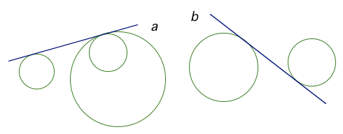

TK#91: Tangent is perpendicular to radius thm: In a plane, a line is tangent to a circle iff the line is perpendicular to a radius of the circle at its endpoint on the circle. Line m is tangent to circle Q iff

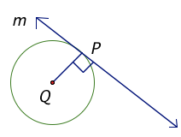

TK#92: Congruent tangents thm: Tangent segments from a common external point are congruent. If and are tangent segments, then
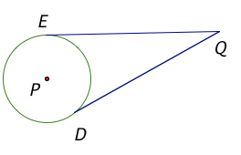

Do page 655 #3-10 orally.

GP 3-9.

10.1 day 1 hwk: pg 655 #11-33 odds, 39, 40
10.1 day 2 hwk: pg 656 #18-40E
10.2 Find arc measures, pg 661 #3-19 odds, 22-24

Read the top of page 659 for the definitions of central angle, minor arc, major arc, semicircle.
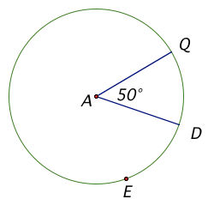

Minor arcs (arcs whose measures are less than 180 degrees) have two letter names, , whereas major arcs (arcs whose measures are greater than or equal to 180 degrees) have 3 letter names, .
TK#93: Def: The measure of an arc is the same as the measure of its central angle.
Find
Find 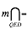

2 circles are congruent if they have the same radius. 2 arcs are congruent if they have the same measures AND they are arcs of the same circle or of congruent circles.

Do GP 2-4 on the back of this page.

Do GP 7,8 on the back of this page.
10.3 Apply properties of chords, pg 667 #3-29 odds (skip 23), 33

Read the top of page 664 about a chord dividing a circle into either 2 semicircles or a minor arc and a major arc.

TK#94: Congruent arcs and chords thm: In the same circle, or in congruent circles, 2 arcs are congruent iff their corresponding chords are congruent. 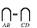iff
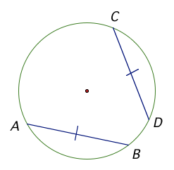
TK#95: Chord as perpendicular bisector thm: If one chord is a perpendicular bisector of another chord, then the first chord is a diameter. If is a perpendicular bisector of , then is a diameter of the circle.
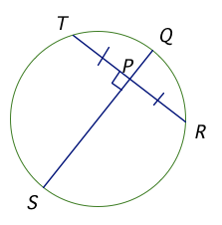
TK#96: Converse of chord as perpendicular bisector thm: If a diameter of a circle is perpendicular to a chord, then the diameter bisects the chord and its arc. If is a diameter and , then and 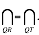
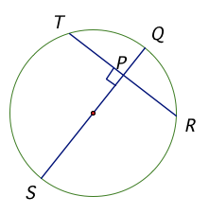
TK#97: Congruent chords are equidistant from the center thm: If the same circle, or in congruent circles, 2 chords are congruent iff they are equidistant from the center. iff EF=EG.
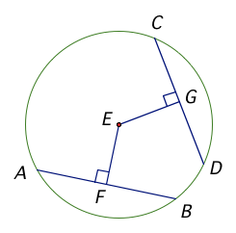

GP 1-8.

Do example 2 (with a compass if times permits).

10.3 day 1 hwk: pg 667 #3-29 odds (skip 23), 33
10.3 day 2 hwk: pg 667 #4-30E (skip 24), 33

_________Quiz 10.3 rev: pg 670 #1-4 and pg 670 #33,35-37 (graph paper)
_________Quiz 10.3 after Activity 10.4 Explore inscribed angles on page 671. Explore 1-3. Draw conclusions 1 and 3. Need compass, straightedge, and protractor.
10.4 Use inscribed angles and polygons, pg 676 #3-35 odds

Def: An inscribed angle is an angle whose vertex is on a circle and whose sides contain chords of the circle. The arc that lies in the interior of an inscribed angle and has endpoints on the angle is called the intercepted arc of the angle. Inscribed angle QED intercepts arc DQ.

Def: A polygon is inscribed if all its vertices lie on a circle. The circle that contains the vertices is a circumscribed circle. The pentagon is inscribed in circle J and the triangle is circumscribed about circle K. Or: Circle J is circumscribed about the pentagon, and circle K is inscribed inside the triangle.
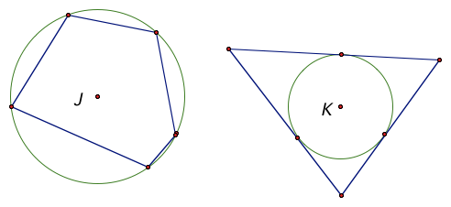
From activity 10.4, we can see that TK#98 and 99 are true.

TK#98: Measure of an inscribed angle thm: The measure of an inscribed angle is one half the measure of its intercepted arc. 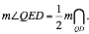
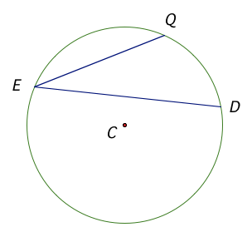
TK#99: Congruent inscribed angle thm: If 2 inscribed angles of a circle intercept the same arc, then the angles are congruent.
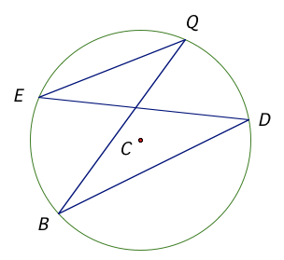
TK#100: Inscribed right angle with hypotenuse diameter thm and its converse: If a right triangle is inscribed in a circle, then the hypotenuse is a diameter of the circle. Conversely, if one side of an inscribed triangle is a diameter of the circle, then the triangle is a right triangle and the angle opposite the diameter is the right angle. iff is a diameter of circle J.
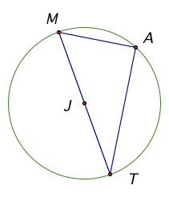
TK#101: Inscribed quadrilateral thm: A quadrilateral can be inscribed in a circle iff its opposite angles are supplementary. Points M, A, T, H lie on circle J iff
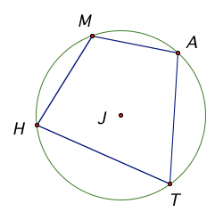

GP 1-3, 6.

10.4 day 1 hwk: pg 676 #3-25 odds, 28-36E
10.4 day 2 hwk: pg 677#16-24E, 27-35 odds
10.5 Apply other angle relationships in circles, pg 683 # 3-29 odds (skip 21)

TK#102: Angles ON the circle thm: If a tangent and a chord or 2 chords intersect ON a circle, then the measure of the angle is one half the measure of its intercepted arc. 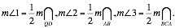
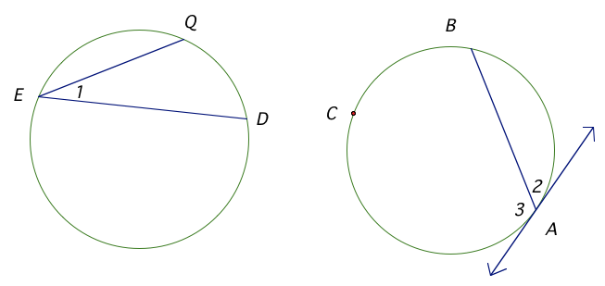
TK#103: Angles INSIDE the circle thm: If 2 chords intersect INSIDE a circle, then the measure of each angle is one half the sum of the measures of arcs intercepted by the angle and its vertical angle. $mÐ4=\frac{1}{2}(m\underset{\text{QD}}{intersect}+m\underset{\text{EB}}{intersect}),mÐ5=\frac{1}{2}(m\underset{\text{BD}}{intersect}+m\underset{\text{EQ}}{intersect})\text{.}$
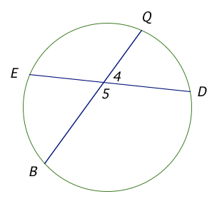

TK#104: Angles OUTSIDE the circle thm: If a tangent and a secant, 2 tangents, or 2 secants intersect OUTSIDE of a circle, then the measure of the angle formed is one half the difference of the measures of the intercepted arcs. $mÐ5=\frac{1}{2}(m\underset{\text{BC}}{intersect}−m\underset{\text{AC}}{intersect}),mÐ6=\frac{1}{2}(m\underset{\text{PQR}}{intersect}−m\underset{\text{PR}}{intersect}),mÐ7=\frac{1}{2}(m\underset{\text{XZ}}{intersect}−m\underset{\text{WY}}{intersect})\text{.}$
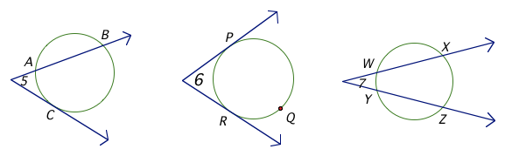

GP 1,2, 4-6.
10.6 Find segment lengths in circles, pg 692 #1-25 odds (skip 19). Bring graph paper tomorrow.
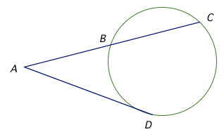
A secant segment $\overline{\text{AC}}$is a segment that contains a chord $\overline{\text{BC}}$of a circle, and has exactly one endpoint outside the circle. The part of a secant segment outside the circle is called an external segment $\overline{\text{AB}}$. $\overline{\text{AD}}$ is a tangent segment.

TK#105: Segments of chords thm: If 2 chords intersect inside a circle, then the product of the lengths of one chord is equal to the product of the lengths of the other chord. (EA)(AD)=(QA)(AB)
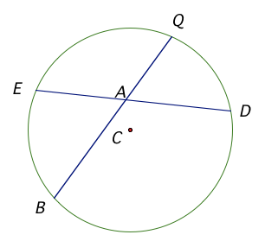
TK#106: Segments of secants thm: If 2 secant segments share the same endpoint outside a circle, then the product of the lengths of one secant segment and its external segment equals the product of the lengths of the other secant segment and its external segment. (VX)(VW)=(VZ)(VY)
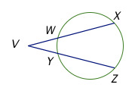

TK#107: Segments of secants and tangents thm: If a secant segment and a tangent segment share an endpoint outside a circle, then the product of the lengths of the secant segment and its external segment equals the square of the length of the tangent segment.
(AC)(AB)=(AD)²

GP 2, 3.

From GP 3: It’s not that x cannot be negative. Rather, no segment or angle can be negative.

Do GP 6, 7 on the back of this page.
10.7 Write and graph equations of circles, pg 702 # 1-33 odds (Need graph paper)

TK#108: Circle equation: $r^{2}=(x−h)^{2}+(y−k)^{2}$ where r=radius, (h,k)=center of the circle, (x,y)=point on the circle.
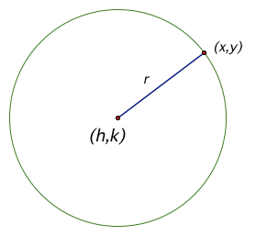
Derive the standard equation of a circle.

Distance formula: $\text{dis}\text{tan}\text{ce}=\sqrt{(x_{1}−x_{2})^{2}+(y_{1}−y_{2})^{2}}$
Let distance between the 2 points=r, point 1=(x,y), point 2=(h,k). Then,
$$r=\sqrt{(x−h)^{2}+(y−k)^{2}}$$
Square both sides to get: $r^{2}=(x−h)^{2}+(y−k)^{2}$

GP 2, 4, 5 (on graph paper), 7. Use the back of this page if you need more space.

10.7 day 1 hwk: pg 702 # 1-31 odds
10.7 day 2 hwk: pg 702 # 4-34E

_____________Ch 10 rev: pg 712 #1-19 all.
_____________ Ch 10 gp quiz. Hwk: pg 716 #1-17 all.
_____________ Correct gp quiz
_____________Turn in TK#1-108. Ch 10 test.

