6.1: Law of Sines, Page 339#1-7odds,21-33odds,45,51.
THE SIX TRIGONOMETRIC RATIOS ONLY WORK IN RIGHT TRIANGLES!
Law of Sines: 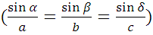
Law of Cosines: 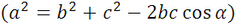 work in any triangle.
With ASA or AAS: Law of Sines gives one unique triangle.
With SSA, Law of Sines gives 0, 1, or 2 triangles.
0 Triangles
1 Triangle

2 Triangles

Ex 1: Solve the triangle with, , and .
Check to make sure no other triangle exists. Work this out at the back of this page.

Ex 2: Solve the triangle with, and .
Check to make sure no other triangle exists. Work this out at the back of this page.
6.2: Law of Cosines, Page 348#3,5,8,11,17-29odds,39,43.

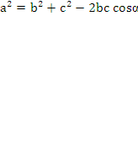

Remember:
1) Law of Cosines ≠ Cosine Ratio
≠ 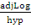
2) Law of Cosines can be used in any triangle.
Cosine ratio can only be used in right triangles.

Proof of Law of Cosines:
Distance formula: d=
Find the Length of a=
Square both sides:
FOIL:
Commutative Property:
Pythagorean Theorem:
Substitution:
Trig. Ratio: cos α= 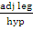=
Solve for h: h=bcosα
Substitution:
Commutative Property:
QED

Ex. 1 Solve the triangle with α=86.0, b=15.0m, c=24.0m. (Find angles in decimal degrees.)

Ex.2 A triangular plot of land has sides a=217ft, b=362ft, c-345ft. Find all three angles to nearest .
6.3 Notes: Areas of ‘s, 6.3. Page 357#1-11odds,20,22.
Rev page395#1,5-9odds,19-25odds,44-48E
Quiz through 6.3

Warm Up: Given: m|| n, find the area of each ▲. What do you notice?
I
II
III
h

b
To find the area of a ▲:
h
b

1.) If base and height are given → A = bh
2.) If SAS are given → A = 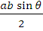
b
a
3.) If SSS are given → Heron’s formula A =
where the semi perimeter →s = 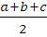

Example 1) Find A of the ▲ with a = 12.0 cm, b= 7.00 cm, and the included angle = 125.0
Work this out at the back of this page.
Example 2) Find A of the ▲ with = 6.0 m, b= 10.0 m, and c = 8.0 m.
Work this out at the back of this page.

6.4 Notes Geometric Vectors, 6.4. Page 365#27-32.

Scalar: can be completely specified by a single real #
Ex. Length, area, volume
Vector: need both a magnitude and a direction for complete specification.
Ex. displacement, velocity, force
A
B
Vector A= initial pt, B= terminal pt
The magnitude of vector is the length.

2 vectors are same direction if they are \\ and point in same direction
2 vectors are opp. direction if they are \\ and point in opposite directions

2 vectors are equal if they have the same magnitude and direction. So a vector can be translated and stay equal.
Ex.
=
5 cm
5 cm

The sum of 2 vectors
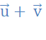
- Tail to tip rule
Ex.

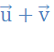
- Parallelogram rule
Ex.

resultant vector; components

Vector addition is communitive and associative:
Ex.1 A powerboat traveling at 35 km/hr has a compass heading of . A strong current, with a compass heading of , is flowing at 8.0 km/hr. Find the resultant velocity.

Ex.2 A man and a horse are pulling a piece of granite. The man is pulling with a force of 200 lb and the horse is pulling with a force of 800 lb away from the direction of the man’s pull. Find the resultant force.

6.5 Algebraic Vectors, 6.5 (on graph paper). Page 376#1-33 odds.
Any vector can be translated into a standard vector with initial point at the origin.
Ex. 1 with A= (4,2), B=(2,-3). Find the coordinates of P so that =

Magnitude or norm of vector = <a,b> = = =
Vector addition: If = <a,b>, = <c,d>, then = <a+c, b+d>
Scalar multiplication: If 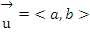 and k is a scalar, then 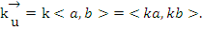
If is a nonzero vector, then 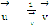is a unit vector with same direction as
The i and j unit vectors: i= <1,0> j= <0,1> y
1 j
0 i 1 x
Ex. 2 Find the magnitude of 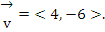

Ex. 3 Let
a)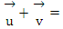
b) -2
c) 2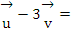
d) 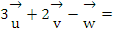
Ex. 4 Find a unit vector with the same direction as vector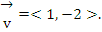

Ex. 5 Express each vector as a linear combination of the i and j vectors.
- <-8, -1> =

- 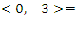

- 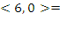

Ex. 6 If 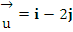, 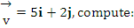
- 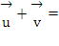

- 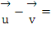

- 2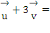
6.6 Notes The Dot Product, 6.6. Page 386#1-25 odds.
Review: page 395#44,45,47,49.53,5-25odds,28,30-34.

Sum of 2 vectors is a vector
Scalar times a vector is a vector
Product of 2 vectors = dot product = scalar product = inner product is a scalar.
The dot product of vectors ,
The angle between 2 nonzero vectors is: 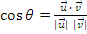
2 vectors are orthogonal iff .
The zero vector is orthogonal to every vector.
The scalar components of , denoted comp_{v}u is:
Or: 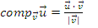
Ex. 1: Find each dot product
- 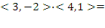

- 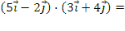

- 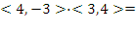

- 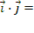

Ex. 2: Find the angle between each pair of vectors (1 dec place)
- 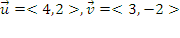

- 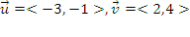

- 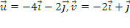

Ex. 3 Determine if each pair of vectors are orthogonal.
- 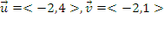

- 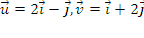

Ex. 4 Find 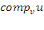 for each pr of vectors 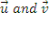. (3 sig figs)
- 

 