$π$ Day Eve Assignment-worth 10 points, due March 13

On $π$ Day Eve, bring enough food or drink (appropriate for school) for 4 people. Before $π$ Day Eve on a sheet of paper, write down why your food or drink involve $π$by doing at least one calculation of your food/drink with $π$ in your final answer.

The following is my example. NO ONE can use it in their assignment!

I brought 4 cans of lemonade. I measured one can and found its height is about 12.4 cm and its diameter is 6.6 cm. The surface area of a can is approximately the same as the surface area of a cylinder, which is $2π\text{rH}+2{πr}^{2}$ where r=radius and H=height.

$${\text{SA}}_{{\text{one}}_{\text{can}}}≈2π(3\text{.}3\text{cm})(\text{12}\text{.}4\text{cm})+2π(3\text{.}3\text{cm})^{2}≈\text{103}\text{.}\text{62}π{\text{cm}}^{2}$$
So the total surface area of all 4 cans of lemonade I brought is about $4(\text{103}\text{.}\text{62}π{\text{cm}}^{2})≈\text{414}\text{.}\text{48}π{\text{cm}}^{2}$.

Make sure you leave your final answer in terms of $π$. Write your name, period, and column number on your paper to turn in at the beginning of the period on $π$ Day Eve.

If you cannot afford to bring food or beverage or 4 people, then see me today or tomorrow before/after school. I will provide the food/drink, and you will do the measurements and calculations.

You can bring your food/drink to class on $π$ Day Eve. If it’s too heavy to carry around, then you can write your name and period on it and drop it off in my classroom before school.
McDougal Geometry chapter 8 notes

8.1 Find angle measures in polygons: pg. 510 #5-17 odds, 18-24E, 29-37 odds (skip 13)

Polygon investigation (need straightedge and protractor).

Each column will be responsible for its assigned polygon. You will use a straightedge to draw your polygon with one set of exterior angles (looks like a pinwheel). You will fill in the following table for your polygon.

Polygon, column # | # of sides | # of triangles | Sum of measures of interior angles | Sum of measures of one set of exterior angles
Triangle:
Column 5
Quadrilateral:
Column 4, 7
Pentagon:
Column 3, 6
Hexagon:
Column 2, 1
Heptagon:

n-gon

Jigsaw to get the rest of the table filled in.

What patterns do you see in the table?

TK#68: Polygon interior angles thm: The sum of the measures of the interior angles of a convex n-gon is $\text{180}°(n−2)\text{.}$

TK#69: Interior angles of a quadrilateral thm: The sum of the measures of the interior angles of a quadrilateral is $\text{360}°\text{.}$

TK#70: Polygon exterior angles thm: The sum of the measures of one set of exterior angles of a convex polygon is $\text{360}°\text{.}$

GP 1-6 (skip 4).

8.1 day 1 hwk: pg. 510 #5-25 odds, 32-35
8.1 day 2 hwk: pg. 511 #28-31,37-47 odds
8.2 Use the properties of parallelograms, pg 518 #3-35 odds, 42,43

Def of parallelogram: a quadrilateral with both pairs of opposite sides parallel. QEDA is a parallelogram because $\overline{\text{QE}}||\overline{\text{AD}}$ and $\overline{\text{QA}}||\overline{\text{ED}\text{.}}$
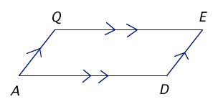

TK#71: Parallelogram properties thm: If a quadrilateral is a parallelogram, then 4 parts are true:
*Part1: its opposite sides are congruent: $\overline{\text{QE}}@{\overline{\text{AD}}}_{{\text{and}}_{\overline{\text{QA}}}}@\overline{\text{ED}}\text{.}$
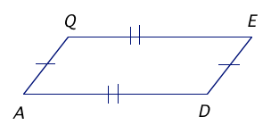
*Part 2: its opposite angles are congruent: $Ð\text{QED}\text{@Ð}{\text{QAD}}_{{\text{and}}_{Ð}}\text{EDA}\text{@Ð}\text{EQA}\text{.}$
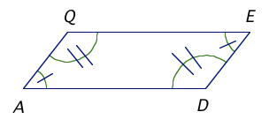
*Part 3: its consecutive angles are supplementary: $\begin{aligned}mÐ\text{QED}+mÐ\text{EDA}=\text{180}°, \\ mÐ\text{EDA}+mÐ\text{DAQ}=\text{180}°, \\ mÐ\text{DAQ}+mÐ\text{AQE}=\text{180}°, \\ mÐ\text{AQE}+mÐ\text{QED}=\text{180}°\text{.}\end{aligned}$
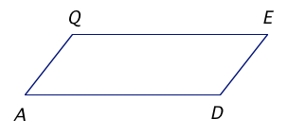

*Part 4: its diagonals bisect each other: $\overline{\text{QM}}@{\overline{\text{MD}}}_{{\text{and}}_{\overline{\text{MA}}}}@\overline{\text{EM}}\text{.}$
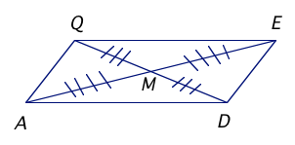

GP 1-6.

If time: Prove Parallelogram properties thm (as many of the 4 parts as possible).
8.3 Show that a quadrilateral is a parallelogram, pg 526 #3-23 odds, 24-28E, 31-39 odds

TK#72: 6 ways to prove that a quadrilateral is a parallelogram:
- Show both pairs of opposite sides are parallel (def of parallelogram).
- Show both pairs of opposite sides are congruent (converse of parallelogram properties thm part 1).
- Show both pairs of opposite angles are congruent (converse of parallelogram properties thm part 2).
- Show all 4 pairs of consecutive angles are supplementary (converse of parallelogram properties thm part 3).
- Show the diagonals bisect each other (converse of parallelogram properties thm part 4).
- Show that one pair of opposite sides are congruent and parallel (One pair of congruent and parallel sides thm).

Solve GP 6 using 2 other methods besides One pair of congruent and parallel sides thm.

GP 1, 2, 5.

If time: prove Converse of parallelogram properties thm part 1.

8.3 day 1 hwk: pg 526#3-39 odds (skip 29)
8.3 day 2 hwk: pg 527#18-40E (skip 30)

8.3 quiz rev pg 532 #1-8 (use graph paper, #8 is a pf).
Quiz through 8.3.
8.4 Properties of rhombuses, rectangles, and squares, pg 537 #1-51 odds, 56,60

Defs: A rhombus is a parallelogram with 4 congruent sides.
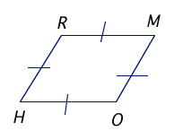
A rectangle is a parallelogram with 4 right angles.
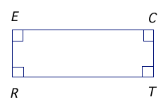
A square is a parallelogram with 4 congruent sides AND 4 right angles.
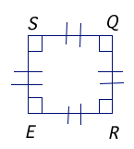
TK#73: Rhombus corollary: A quadrilateral is a rhombus iff it has 4 congruent sides. RHOM is a rhombus iff $\overline{\text{RH}}@\overline{\text{HO}}@\overline{\text{OM}}@\overline{\text{MR}}\text{.}$
TK#74: Rectangle corollary: A quadrilateral is a rectangle iff it has 4 right angles. RECT is a rectangle iff $ÐR,ÐE,ÐC,ÐT$ are right angles.

TK#75: Square corollary: A quadrilateral is a square iff it is both a rhombus AND a rectangle. SQRE is a square iff $\overline{\text{SQ}}@\overline{\text{QR}}@\overline{\text{RE}}@\overline{\text{ES}}$ AND $ÐS,ÐQ,ÐR,ÐE$ are right angles.

TK#76: Parallelogram-rhombus thm: A parallelogram is a rhombus iff:
*Part 1: its diagonals are perpendicular. Parallelogram ABCD is a rhombus iff $\overline{\text{AC}}\hat{\overline{\text{BD}}}\text{.}$
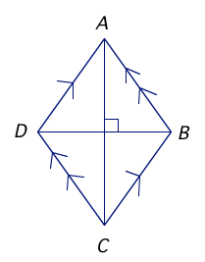
*Part 2: each diagonal bisects a pair of opposite angles. Parallelogram ABCD is a rhombus iff ${\overline{\text{AC}}}_{\text{bi}}\text{sec}{\text{ts}}_{Ð}{\text{BCD}}_{{\text{and}}_{Ð}}{\text{BAD}}_{{\text{and}}_{}}\text{sec}{\text{ts}}_{Ð}{\text{ABC}}_{{\text{and}}_{Ð}}\text{ADC}\text{.}$
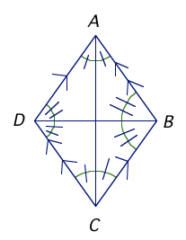

TK#77: Parallelogram-rectangle thm: A parallelogram is a rectangle iff its diagonals are congruent. Parallelogram RECT is a rectangle iff $\overline{\text{RC}}@\overline{\text{TE}}\text{.}$
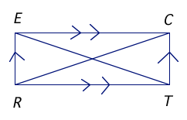

GP 1-4.

(If time) Prove: If the diagonals of a parallelogram are perpendicular, then the parallelogram is a rhombus.

8.4 day 1 hwk: pg 537 #1-49 odds, 56, 60
8.4 day 2 hwk: pg 538 #30-50E, 61,62
8.5 Use properties of trapezoids and kites, pg 546 #3-41 odds (skip 33)

Def: A trapezoid is a quadrilateral with exactly one pair of parallel sides called bases $\overline{\text{TR}},\overline{\text{PA}}$. The nonparallel sides are called legs $\overline{\text{TP}},\overline{\text{RA}}$. There are 2 pairs of base angles: ${ÐT}_{{\text{and}}_{ÐR}},{ÐP}_{{\text{and}}_{ÐA}}\text{.}$ The midsegment of a trapezoid connects the midpoints of its legs $\overline{\text{MN}}$.
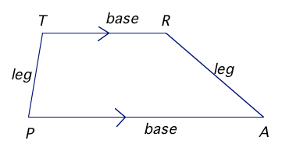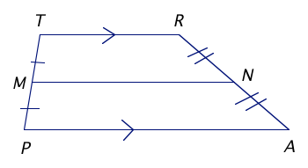

Def: A kite is a quadrilateral that has 2 pairs of consecutive congruent sides, but opposite sides are NOT congruent.
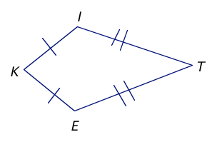

TK#78: Isosceles trapezoid congruent base angles thm: If a trapezoid is isosceles, then each pair of base angles is congruent. If trap ISOT is isosceles, then $ÐT\text{@Ð}O_{{\text{and}}_{ÐI}}\text{@Ð}S\text{.}$
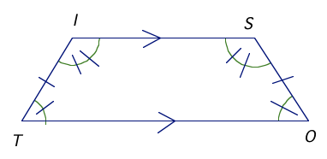
TK#79: Converse of isosceles trapezoid thm: If a trapezoid has a pair of congruent base angles, then it is an isosceles trapezoid. If $ÐT\text{@Ð}O({\text{or}}_{ÐI}\text{@Ð}S)$, then trapezoid ISOT is isosceles.

TK#80: Isosceles trapezoid congruent diagonals thm: A trapezoid is isosceles iff its diagonals are congruent. Trapezoid ISOT is isosceles iff $\overline{\text{TS}}@\overline{\text{IO}}\text{.}$
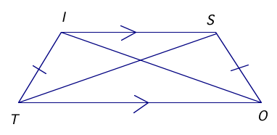
TK#81: Midsegment thm for trapezoids: The midsegment of a trapezoid is parallel to each base and its length is half the sum of the lengths of the bases. If $\overline{\text{MN}}$ is the midsegment of trapezoid TRAP, then $\overline{\text{MN}}||\overline{\text{TR}},\overline{\text{MN}}||{\overline{\text{PA}}}_{{\text{and}}_{\text{MN}}}=\frac{1}{2}(\text{TR}+\text{PA})\text{.}$
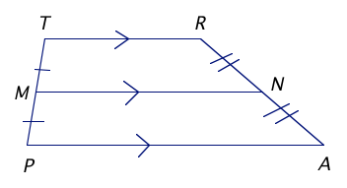
TK#82: Kite thm: If a quadrilateral is a kite, then:
*Part 1: its diagonals are perpendicular. If quadrilateral KITE is a kite, then $\overline{\text{KT}}\hat{\overline{\text{IE}\text{.}}}$
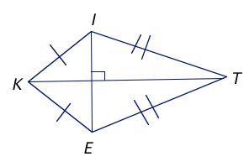
*Part 2: exactly one pair of opposite angles is congruent. If quadrilateral KITE is a kite, then $ÐI\text{@Ð}E_{{\text{and}}_{}}\text{.}$
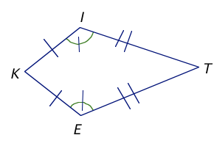
GP 1-6.

8.5 day 1 hwk: pg 546#3-31 odds, 38,40
8.5 day 2 hwk: pg 547#26-36E (skip 32), 37-41 odds
8.6 Identify special quadrilaterals, pg 554 #1-21 all, 27, 33-39 odds

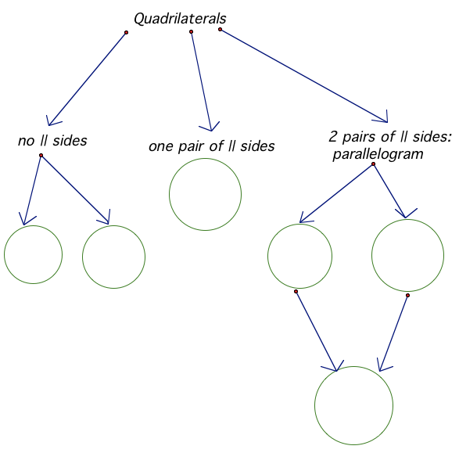

GP 1-5.

____________Ch 8 gp quiz. Hwk: ch 8 rev pg 560#1-28. Print out ch 9 notes.
____________ Turn in ch 9 notes. Correct gp quiz.
____________ Turn in TK#1-82. Ch 8 test.Read Draw 3-D figures on pg 550-551 and do 1-12. (Need isometric dot paper.)

