Dear Parents and Students,
About the Course
Digital Animation is an elective course offered to 8th grade students. Students enrolled in this course will learn to create animated short films using the principles of animation through the visual electronic art form of 2D animation. The software program to be used in this course is Flip Boom All Star. Students will learn to sketch cartoons, simple animation terminology, storyboarding techniques as well as the history of and cultural influences on the field of animation. This is a “hands on” course intended to expose students to the world of animation and to prepare them for more specialized concepts introduced at the high school level and beyond.
Room 503 is a PC lab that uses Microsoft Windows 7 and Flip Boom All Star Digital Animation software.
Materials
All textbooks and skill-building software will be provided to each student for use in the computer lab only. It will not be necessary for students to take any materials home.
Donations
Elective courses, including Business Technology, rely heavily on donations from parents and the community to help offset the cost to replace lost or damaged items or replenish stock on hardware used in the lab on a daily basis. The suggested donation for the school year is $5.00. If you would prefer to donate an item instead, please allow me to suggest the following: colored pencils, sketchbook paper, number 2 pencils, white copier paper for laserjet printers, headphones, keyboard speedskin covers, and flash drives (2 GB or larger.) Your donation is much appreciated! The donation for the school year is due ON OR BEFORE Friday, October 4, 2013.
Grading Policy
Students will be given a letter grade based on completion of daily assignments, vocabulary words, quizzes, tests, and projects. PLEASE NOTE: Nearly all computer assignments will be completed in the classroom. Student attendance is encouraged and poor attendance and/or excessive tardiness to class will negatively affect the students’ grade. The grading scale is as follows
A = 100 -90% | B = 89 – 80% | C = 79 – 67% | D = 66 – 60% | F = 59 – 0%
Classroom Rules
Responsible behavior is expected in the computer lab, always!
Rules are posted in the lab and are listed below:
- Arrive to class on time—be seated at your workstation BEFORE the bell rings!
- Food, drink, gum, etc. are NOT allowed in the computer lab.
- Personal grooming is not allowed in the computer lab.
- Be prepared with the proper materials! This includes paper, pen, pencil, etc.
- Turn in ALL assignments in on time!
- Treat other students and teachers the way that you want to be treated!
- Any rule deemed necessary by Mrs. Shaw.
Mrs. Shaw’s Contact Information
Conference: Period 3 – 9:30 a.m. – 10:15 a.m., daily
I check my email several times per day. E-mail is the quickest way to contact me! If you would like to contact me via e-mail please use the following address: shaw_c@auhsd.us
If you would like to speak with me directly, please call before or after school or during one of my conference periods. My contact phone number is: 714-999-3667.
Also, for up to the minute information, please view my WIKI website:

Mrs. Shaw’s WIKI Website
www.shawcomputerskills.wikispaces.com

South Junior High School
General Information
2320 South Street
Anaheim, California 92806
Main Office: 714-999-3667
Administration | Counselors
Carlos Hernandez, Principal | Cecilia Soberanis (A–L)
Jana Kovar, Assistant Principal (A-L) | Candace Dion (M-Z)
Enrique Romero, Assistant Principal (M-Z) | April Hancock (T, W, Th)
DO YOU HAVE A QR READER?
Quickly download and save Mrs. Shaw’s contact information by scanning the barcode below!
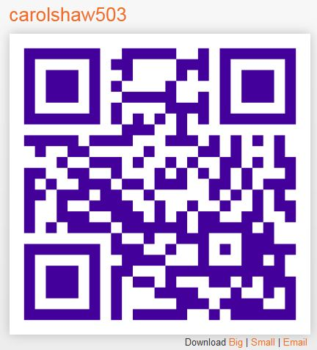

Don’t have a QR Reader? Download a QR Reader application for FREE from your SmartPhone!

 - - - - - - - - - - - - - - - - - - - - - - - - - - - - - - - - - - - - - - - - - - - - - - - - -
Please cut along the dotted line and return to Mrs. Shaw by Friday, September 6, 2013.

I have read and I understand what is written in the curriculum paper presented above. If I have any questions, I know that I may contact Mrs. Shaw at 714-999-3667.

Parent Signature Student Signature Period

Parent Phone Number:

Parent E-mail Address:
If available

Student E-mail Address:
If available

