Name:_____________
Date:_____________
Period: ________

Map of Italy
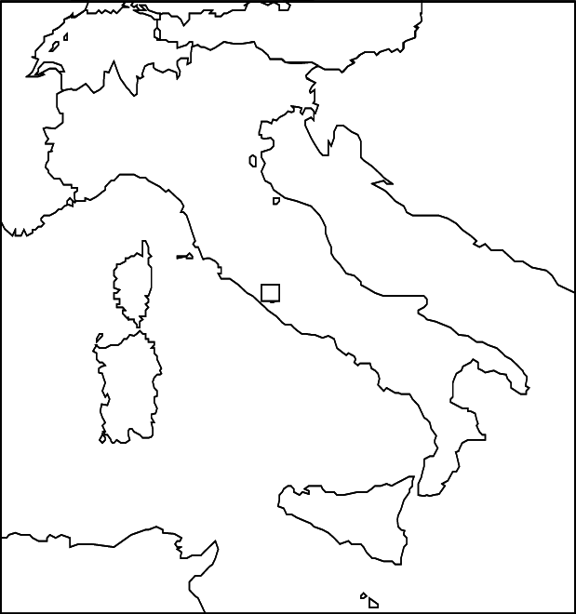

Map of Italy during Renaissance Period

Points: _____________ 2 points for following directions
18 points for correctly placing locations

Please use the map on page 385 in your textbook. Please locate and label places first, then highlight the location, and then color.

1. Please label the first 6 cities with a black dot and the other 2 with an asterisk (*) or star.

Milan * Venice
Genoa * Florence
Pisa
Rome
Naples
Siena

2. Please label the following 2 mountain ranges and color them with brown triangles.

Alps
Apennines

3. Please label the following 2 countries and 3 islands and color them green.

Swizterland (p. 66) Sicily
Italy Sardinia
Corsica

4. Please label the following 3 bodies of water and color them blue.

Mediterranean Sea Tyrrhenian Sea
Adriatic Sea

