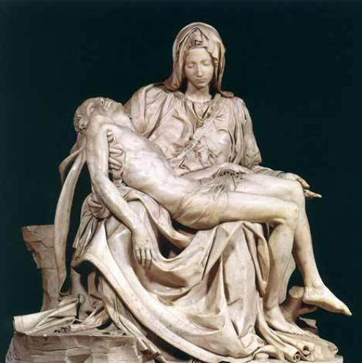

Michelangelo’s sculpture, Pieta, c. A.D. 1498. This masterpiece represents the Virgin Mary holding Jesus in her lap after he has been crucified. It was made for a cardinal’s tomb in St. Peter’s Church in Rome.

