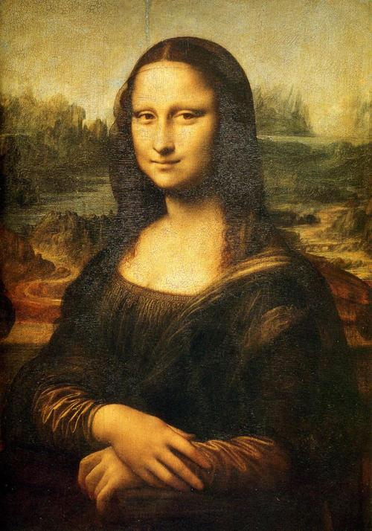

Painted by Leonardo da Vinci c. 1503. This painting was bought by the king of France. The painting depicts a seated women named Lisa Giocondo.

