The Last Supper by Leonardo Da Vinci, 1498 – One of the worlds most well known paintings, this piece depicts Jesus gathered with his 12 disciples at the monment where he announced that one of his followers had betrayed him.
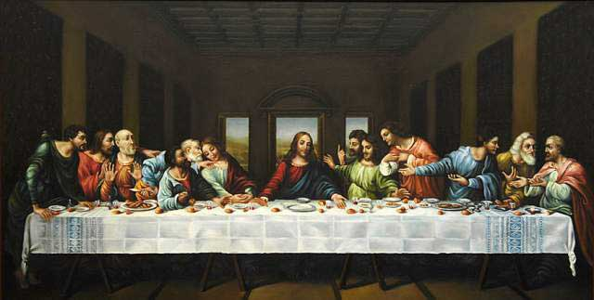
This piece is a 15 x 29 foot frescoe completed on the wall of the convent of Santa Maria delle Grazia in Milan, Italy.

